Experiment No. 12
Aim: Design and development of an application demonstrating multithreading.
1. Write a program that bounces a blue ball inside a JPanel. The ball should begin moving with a mousePressed event. When the ball hits the edge of the JPanel, it should bounce off the edge and continue in the opposite direction. The ball should be updated using a Runnable.
import javax.swing.*;
import java.awt.*;
import java.awt.event.MouseAdapter;
import java.awt.event.MouseEvent;

public class BouncingBall extends JPanel implements Runnable {

private int x = 50, y = 50; // Ball position
private int dx = 3, dy = 3; // Direction & speed
private final int SIZE = 30; // Ball size
private boolean running = false;

private Thread animator;

public BouncingBall() {
setBackground(Color.WHITE);

// Start animation on mouse press
addMouseListener(new MouseAdapter() {
@Override
public void mousePressed(MouseEvent e) {
if (!running) {
running = true;
animator = new Thread(BouncingBall.this);
animator.start();
}
}
});
}

@Override
protected void paintComponent(Graphics g) {
super.paintComponent(g);

// Draw blue ball
g.setColor(Color.BLUE);
g.fillOval(x, y, SIZE, SIZE);
}

@Override
public void run() {
while (running) {
moveBall();
repaint();

try {
Thread.sleep(10); // control speed
} catch (InterruptedException e) {
e.printStackTrace();
}
}
}

private void moveBall() {
x += dx;
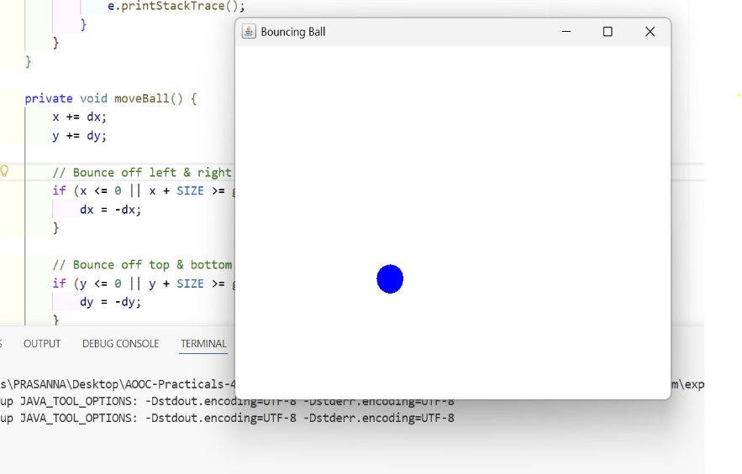
y += dy;

// Bounce off left & right walls
if (x <= 0 || x + SIZE >= getWidth()) {
dx = -dx;
}
// Bounce off top & bottom walls
if (y <= 0 || y + SIZE >= getHeight()) {
dy = -dy;
}
}
public static void main(String[] args) {
JFrame frame = new JFrame("Bouncing Ball");
BouncingBall panel = new BouncingBall();
frame.add(panel);
frame.setSize(500, 400);
frame.setDefaultCloseOperation(JFrame.EXIT_ON_CLOSE);
frame.setLocationRelativeTo(null);
frame.setVisible(true);
}
}
2. Create an application of Stopwatch using the concept of Multithreading.
import javax.swing.*;
import java.awt.*;
import java.awt.event.ActionEvent;
import java.awt.event.ActionListener;

public class StopwatchApp extends JFrame implements Runnable {

private JLabel timeLabel;
private JButton startBtn, stopBtn, resetBtn;

private int seconds = 0;
private boolean running = false;
private Thread timerThread;

public StopwatchApp() {
setTitle("Stopwatch");
setSize(300, 200);
setDefaultCloseOperation(JFrame.EXIT_ON_CLOSE);
setLocationRelativeTo(null);
// UI Setup
timeLabel = new JLabel("00:00:00", SwingConstants.CENTER);
timeLabel.setFont(new Font("Arial", Font.BOLD, 30));

startBtn = new JButton("Start");
stopBtn = new JButton("Stop");
resetBtn = new JButton("Reset");

JPanel buttonPanel = new JPanel();
buttonPanel.add(startBtn);
buttonPanel.add(stopBtn);
buttonPanel.add(resetBtn);

add(timeLabel, BorderLayout.CENTER);
add(buttonPanel, BorderLayout.SOUTH);

// Button Actions
startBtn.addActionListener(new ActionListener() {
public void actionPerformed(ActionEvent e) {
if (!running) {
running = true;
timerThread = new Thread(StopwatchApp.this);
timerThread.start();
}
}
});
stopBtn.addActionListener(new ActionListener() {
public void actionPerformed(ActionEvent e) {
running = false;
}
});
resetBtn.addActionListener(new ActionListener() {
public void actionPerformed(ActionEvent e) {
running = false;
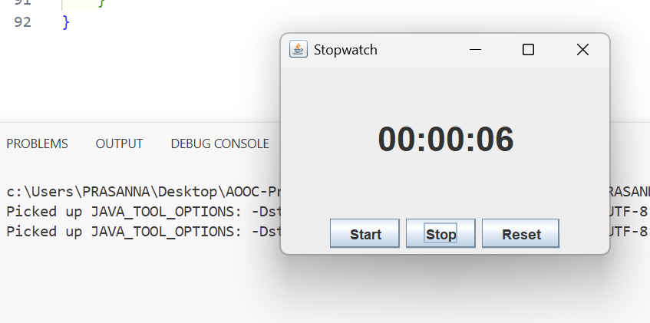
seconds = 0;
updateLabel();
}
});
}
@Override
public void run() {
while (running) {
seconds++;
updateLabel();
try {
Thread.sleep(1000); // 1 second delay
} catch (InterruptedException e) {
e.printStackTrace();
}
}
}

private void updateLabel() {
int hrs = seconds / 3600;
int mins = (seconds % 3600) / 60;
int secs = seconds % 60;

String time = String.format("%02d:%02d:%02d", hrs, mins, secs);
timeLabel.setText(time);
}

public static void main(String[] args) {
SwingUtilities.invokeLater(() -> {
new StopwatchApp().setVisible(true);
});
}
}

